Core Concepts and Architecture
- Azure Storage does not use traditional Storage Area Networks (SANs) or Network Attached Storage (NAS) as used in most data centres, except for Azure NetApp Files.
- Storage is delivered through software-defined storage clusters called Storage Stamps, which provide scale, durability, and replication.
Storage Stamp three-tier architecture:
  - Stream Layer: Represents actual bits on the disk and is an ordered list of storage chunks that is made up of various blocks. Handles actual data storage, replication, and durability.
  - Partition Layer: Understand and manages the constructs/abstractions we interact with like blobs, tables, queues. Provides scalable namespace.
  - Front End Layer: Stateless API request handling, authentication, and routing to partition layer.
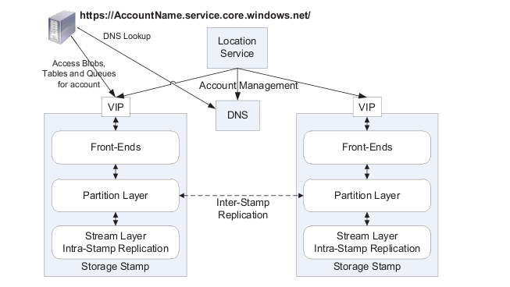
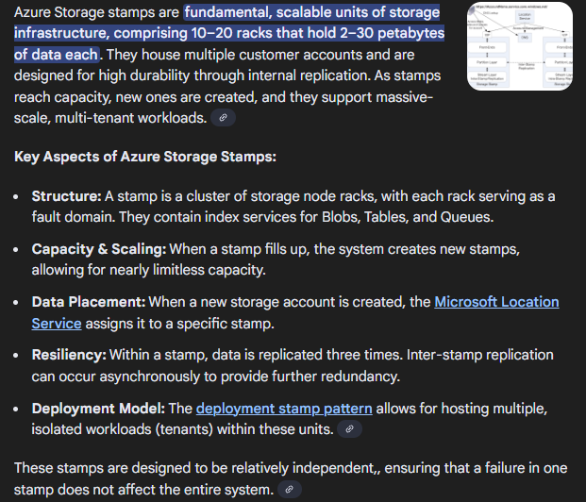

- DNS is used for namespace of storage account which is why URIs are used to access.
http(s)://<accountName>.<service>.core.windows.net/<partition>/<object>
<service> will be like blob, file.
- Azure Storage accounts are region-specific and grouped within Resource Groups.
- Data is replicated in 2 ways:
- Intra-stamp replication (stream layer) – synchronous – 3 copies always in same region – can be LRS or ZRS.
- Inter-stamp replication (partition layer) – asynchronous – 3 copies in paired region, in addition to 3 copies in same region. Used in GRS
- Data durability is extremely high (e.g., 11 nines for LRS) with different replication options influencing availability and cost.
- Storage account is the top level namespace for storage services. It’s mapped to a region and resource group. Can enable metric and monitoring on them.

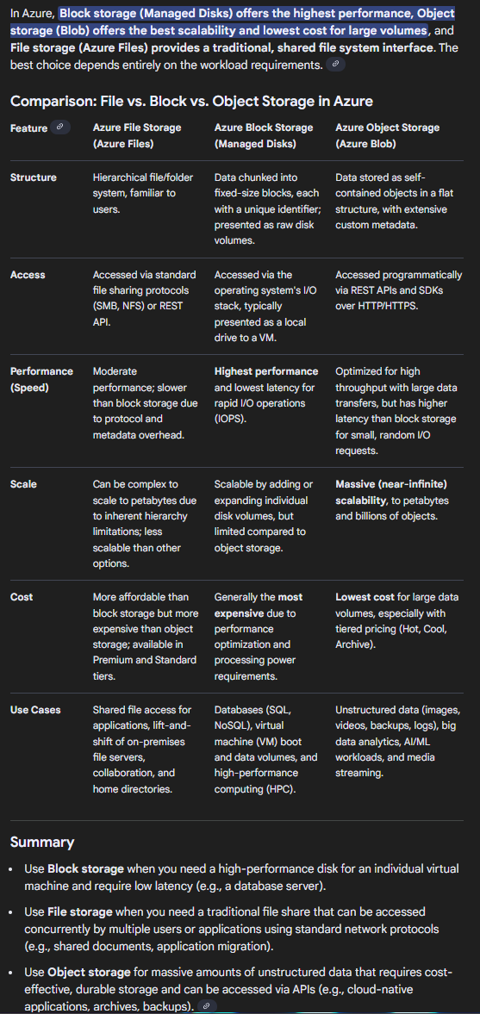
Types of Data and Storage
Data Types:
  - Unstructured: Media files, images, videos, binaries (stored in blobs).
  - Structured: Relational databases with fixed schemas (tables).
  - Semi-structured: JSON/XML documents with self-describing schema.
Storage Types:
  - Ephemeral: Temporary, volatile storage (e.g., cache, page files).
  - Durable: Persistent storage on disks or tapes.
Azure Storage Account Services:
  - Blob Storage: For large amounts of unstructured data.
  - File Storage: SMB/NFS shares for file-based storage.
  - Table Storage: NoSQL key-value store (less used; Cosmos DB preferred).
  - Queue Storage: Simple FIFO messaging (less used; Service Bus preferred). Useful in event driven architecture.
  - Managed Disks: Abstracted disks for VMs.
  - Azure Elastic SAN: Block storage solution using iSCSI for high-performance workloads.
  - Azure NetApp Files: High-performance file shares with native NetApp filers.

Storage Account Types and Performance Tiers
Storage Account Type | Supported Services | Performance | Billing Model | Notes
General Purpose v2 (Standard) | Blob, File, Queue, Table | Standard | Pay-as-you-go | Most common
Premium Blob | Block Blob only | Premium (high perf) | Pay-as-you-go | Only block blobs
Premium File | File shares | Premium | Provisioned | For SMB/NFS with premium speed
Premium Page Blob | Page blobs | Premium | Provisioned | Used less, replaced by managed disks
File Storage Provisioned V2 | Files | Provisioned dynamic iops | Provisioned | Pay for capacity, IOPS, throughput
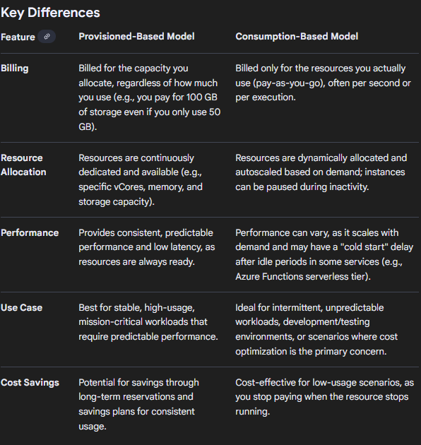
- Tiers for Blob Storage: Hot, Cool, Cold, Archive (varying cost and access latency)(configured per blob)
- Tiers for File Storage: Transaction Optimized, Hot, Cool (configured at share level).
- Tiers help balance the need to store and have the data available – with how much you intend to interact with the data. Hot/cool for new data with more interaction, cold for less interaction while still having instant access, archive (offline – need to be rehydrated to other tier first).
- Premium tiers offer higher performance at a higher cost and different billing models (provisioned vs. consumption-based).

Resiliency and Replication Options
Replication Type | Description | Copies | Durability (approx.) | Sync/Async | Secondary Read Access | Notes
LRS (Locally Redundant Storage) | Data replicated 3 times within a single storage cluster | 3 | 11 nines | Synchronous | No | Lowest cost, single cluster
ZRS (Zone-Redundant Storage) | 3 copies across 3 availability zones within the same region | 3 | 12 nines | Synchronous | No | Higher availability & durability
GRS (Geo-Redundant Storage) | 3 copies in primary + 3 copies asynchronously in paired region | 6 | 16 nines | Async | Optional | Geo-redundancy; secondary read possible
GZRS (Geo-Zone-Redundant Storage) | Combines ZRS in primary + LRS in paired region | 6 | 16 nines | Async | Optional | Hybrid combining zone and geo redundancy
- Azure allows customer-managed failover for geo-redundant accounts.
- Secondary endpoints can be used for “secondary read access” on blob, queue, and table services (not for files), in the paired region. In full regional failover, primary endpoint will point to paired region.

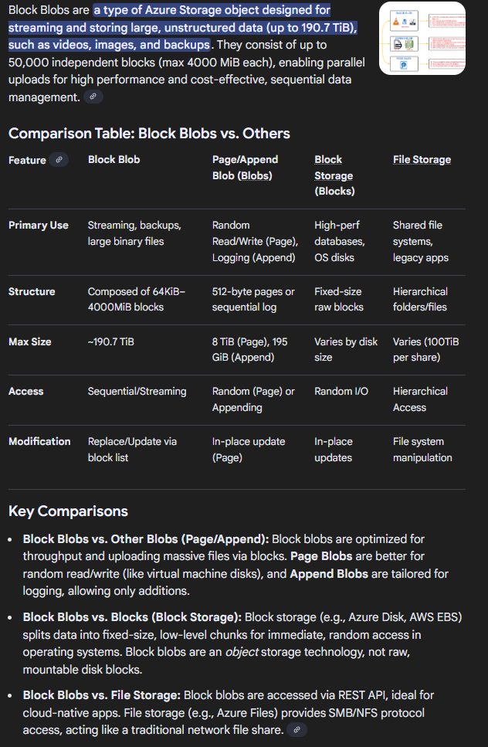
Advanced Features and Capabilities
- Object Level Replication (OLR): Allows asynchronous replication of block blobs / containers between arbitrary storage accounts (not limited to paired regions). Flexibility in which blobs are replicated.
- Containers organize blobs, similar to directories in a file system. (In case of HNS, containers become like folders). A storage account can contain unlimited containers, and a container can store an unlimited number of blobs. Files are uploaded into containers as block blobs via the Azure Portal, CLI, or API.
Blob (Binary Large Object) Types:
  - Block Blob: Most common, optimized for large unstructured data. Formed of different size blocks.
It is a flat namespace and no concept of actual directories (virtual directories are there in UI).
  - Page Blob: Optimized for random read/write (used internally for managed disks).
  - Append Blob: Optimized for append operations (e.g., logging).
- Hierarchical Namespace (HNS): Enables a true directory/folder structure in Blob Storage, foundational for Azure Data Lake Storage Gen2.
Supports POSIX-style ACLs, NFS 3.0, and SFTP. Improves file operations such as move, rename, and access control. Moving a file/folder in regular blob virtual directory actually copies all blobs to new file and delete original – big operation. But in HNS with true directory, it is just a metadata chnage and very fast. HNS also enables big data analytics with tools like Hadoop, Spark, and Databricks.
Blob Index Tags: Metadata key-value pairs for tagging blobs, supporting indexing and attribute-based access control.

Security and Access Control
Access Methods:
  - Storage Account Access Keys: Two all-powerful keys with rotation capabilities (use discouraged).
  - Azure AD (Entra) Integration: Role-Based Access Control (RBAC) on data plane for granular permissions.
  - Shared Access Signatures (SAS): Limited scoped, time-bound tokens signed by account keys. So breaks if access key is rotated.
Encryption:
  - At Rest: Always enabled by default using AES-256; supports Microsoft-managed or customer-managed keys (CMK) in Azure Key Vault. Storage account data can’t be not encrypted. Can have double encryption (only at time of SA creation) called infrastructure encryption.
  - Double Encryption: Can have double encryption (only at time of SA creation) called infrastructure encryption.
  - Encryption Scopes: Allows different encryption keys per container or blob in storage account. You can use them to create secure boundaries b/w data that reside in same storage account but belong to different customers.
  - In Transit: TLS enforced (HTTPS for blobs, SMB3 for files).

Networking and Access Restrictions
Every azure resource providing some service has a Native firewall capability. Azure Storage account supports access restrictions via:
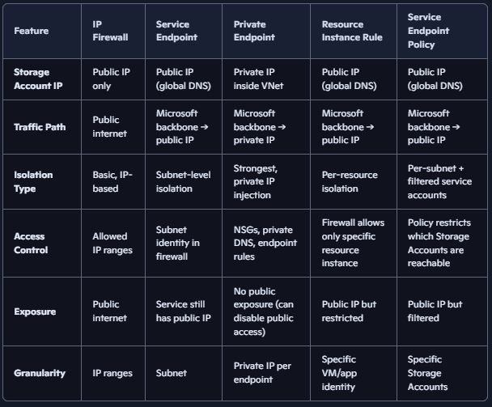
  - IP-based firewalls - allows/denies traffic based on public IP addresses. Allowed IP ranges are configured, only request from those can reach SA.
  - Service Endpoints: Every Azure Storage Account is exposed via a public IP address (behind a DNS name like mystorage.blob.core.windows.net). That public IP is owned by Microsoft and reachable globally. When you enable a service endpoint on a subnet, traffic from that subnet to the Storage Account is forced onto the Microsoft backbone network instead of traversing the public internet. Storage firewall can then allow traffic only from that subnet in vnet. Subnet-level granularity, not per-resource.
  - Private Endpoints (Private Link): A private endpoint creates a NIC with a private IP address inside your Vnet. That private IP is mapped directly to the Storage Account service. When your VM in the subnet accesses the Storage Account, DNS resolves to the private IP. Traffic flows entirely inside your VNet to the private endpoint NIC, then across Microsoft’s backbone to the Storage Account. The Storage Account is no longer exposed via its public IP for that connection. The Storage Account firewall can be configured to allow only private endpoint connections.
  - Resource Instance Rules: Fine-grained firewall rules that allow access only from specific resource instances (e.g., a VM or Function App). Instead of allowing an entire subnet, you whitelist a single resource identity. Storage firewall enforces that only that resource can connect.
  - Service Endpoint Policies: Prevent data exfiltration by restricting service endpoints to specific storage accounts. Filters applied to service endpoint traffic. Subnet has a service endpoint for Storage.
Attach a service endpoint policy to that subnet. Policy restricts which specific Storage Accounts can be accessed. Example: Subnet can reach Storage, but policy allows only storageacct1 and blocks storageacct2.

Cost Optimization and Management
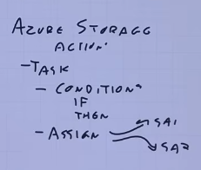
- Lifecycle Management: Using defined rules, automates moving blobs between tiers (hot → cool → archive) and deletion based on last modified, created, or accessed timestamps. Eg – after 15 days of no access move blobs from hot to cool, then to cold after 45 days. Delete after 365 days.
- Azure Storage Actions: Extends lifecycle management with more complex policies, immutability, legal holds, and blob tagging.
Billing Models:
  - Capacity-based (provisioned)
  - Consumption-based (pay per use)
  - Network egress charges apply for geo-replication and cross-region data transfer.

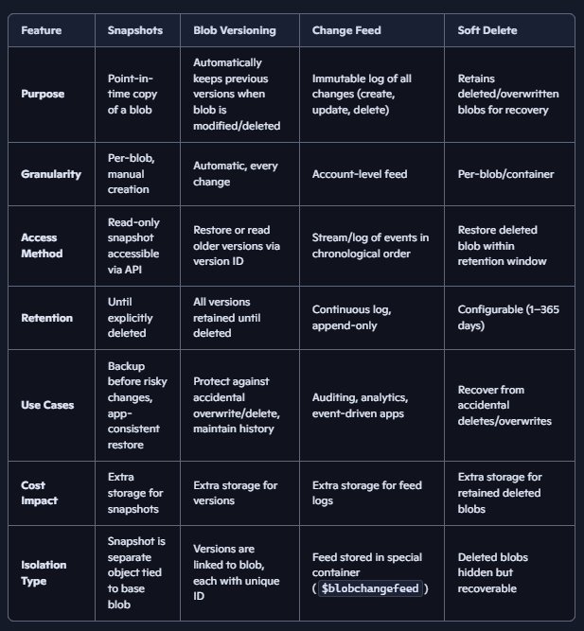
Data Protection and Recovery
- Snapshots: Point-in-time read-only copies. incremental storage (pay only for change in data).
- Blob Versioning: Automatically maintains previous versions whenever a blob is modified or deleted. Provides point-in-time recovery without manual snapshot creation. You don’t control when versions are created — they happen on every change. Snapshots give you intentional checkpoints.
- Change Feed: An immutable, append-only chronological log of all blob changes in an account. enabling event-driven processing (e.g., track all blob uploads/deletes) and analytics.
- Soft Delete: Enables recovery of deleted blobs as it retains deleted or overwritten blobs for a configurable retention period (1–365 days).

Specialized Services and Use Cases
- Azure File Sync: Syncs on-premises Windows file shares with Azure Files, supports multi-server sync groups and cloud tiering (local cache + cloud storage).
- Azure Elastic SAN: High-performance, iSCSI-based block storage for workloads like Azure VMware Solution. It runs on azure storage and has the redundancy options (LRS/ZRS) available as well. While creating elastic SAN, Create volume groups (it defines n/w and security boundary) and volumes, then clients connect to it via iscsi.
NOTE: In block storage system, the connecting client sees a disk and is responsible for interacting directly with the blocks on it and having various filesystem on top of it. (compared to file base where client just talk to an Api and sees files/folders)
- Azure NetApp Files: Netapp filers are present in azure data centres. Enterprise-grade file storage with SMB/NFS support, multiple service tiers (Standard, Premium, Ultra), and cold data tiering capabilities.

Virtual Machine Storage Integration
- Managed Disks: Managed disks are Azure’s recommended disk storage offering for VMs. They abstract away the complexity of manually creating and managing storage accounts + page blobs. Without managed disks: You had to create a storage account. Inside it, create a page blob (special blob type optimized for random read/write). Attach that page blob to a VM as a disk.
- Types: Standard HDD, Standard SSD, Premium SSD v1/v2, Ultra Disk. Azure automatically handles storage account creation, scaling, and placement. Built-in availability, encryption, snapshots, backups. Easy to attach/detach to VMs. Integrated with RBAC, Azure Backup, and Shared Disks. Performance scales with disk size and SKU; supports bursting (burst up to higher performance for limited time), dynamic IOPS/throughput (Premium SSD v2 and Ultra). Premium SSD v1 allows changing performance (IOPS/throughput), without needing to change capacity.
- Disks can be encrypted using customer-managed keys (disk encryption sets).
- Ephemeral OS Disks: Use host local cache for non persistent high-performance OS disk (if state is not required), without managed disk costs. Most VMs have temporary drive D: or /dev/sdb1 (by default) which is not persistent across restarts.
- VM network bandwidth and NIC limits impact performance of network-based storage protocols (SMB, NFS, iSCSI). VM itself also has storage performance characteristics (supported IOPS/throughput). So attaching high performance disks beyond a limit is not helpful as VM may become bottleneck.

Tooling and Migration
- Azure Storage Explorer: Free tool for managing storage accounts, blobs, queues, tables, and files with support for SAS, keys, and Azure AD authentication.
- AzCopy: Command-line tool for efficient server-side copying and syncing between storage accounts or from external clouds (AWS, Google). Has sync mode to replicate changes.
- Azure Storage Mover: Managed migration tool for SMB and NFS shares from on-premises to Azure Blob or File storage. Need TCP/443 outbound from mover agent. Maintains structure, permissions and metadata. Storage mover can work with Azure Data Box which enables offline data transfer appliance for large-scale data import/export to Azure. Encrypted using bitlocker.

Data Governance
- Microsoft Purview: Data governance solution enabling data discovery, classification, labeling, data loss prevention, rights management across Azure and hybrid environments.
- Supports hundreds of built-in and custom classifications, policies, and unified data catalog.
